**VPC with public and private subnets**

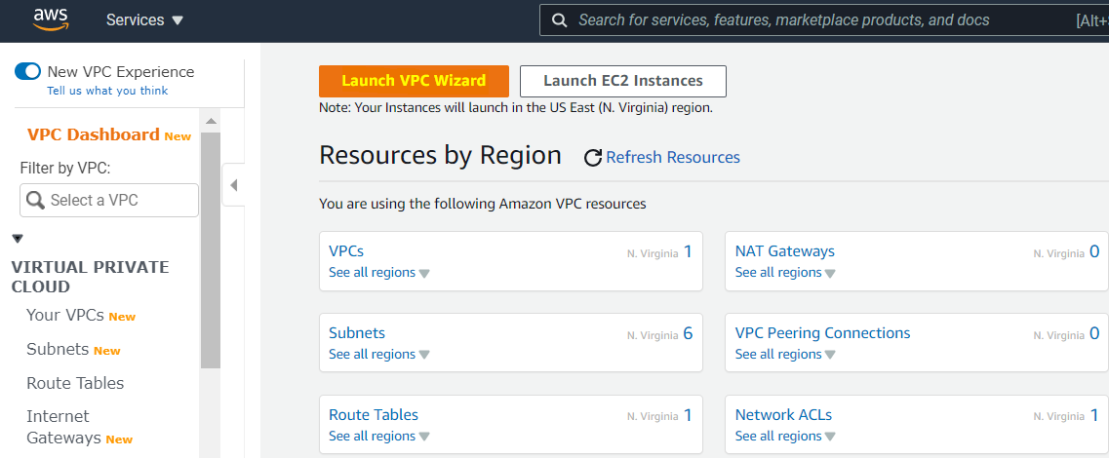

Alternate way to create VPC choose “VPC with public and private subnets”. It will vpc, subnet, IGW and route table:

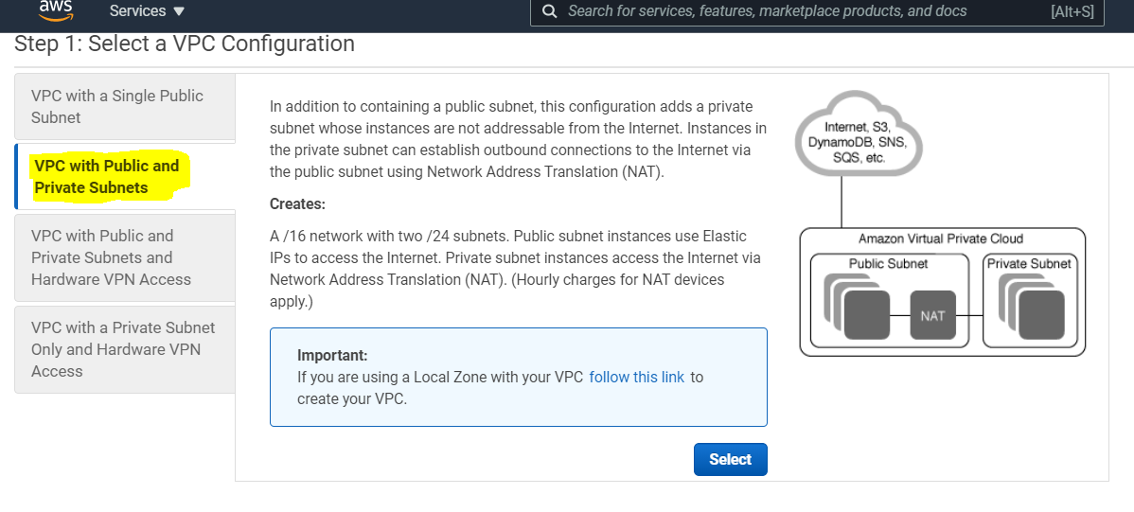

Enter your CIDR blocks and choose NAT gateway instance for free cost:

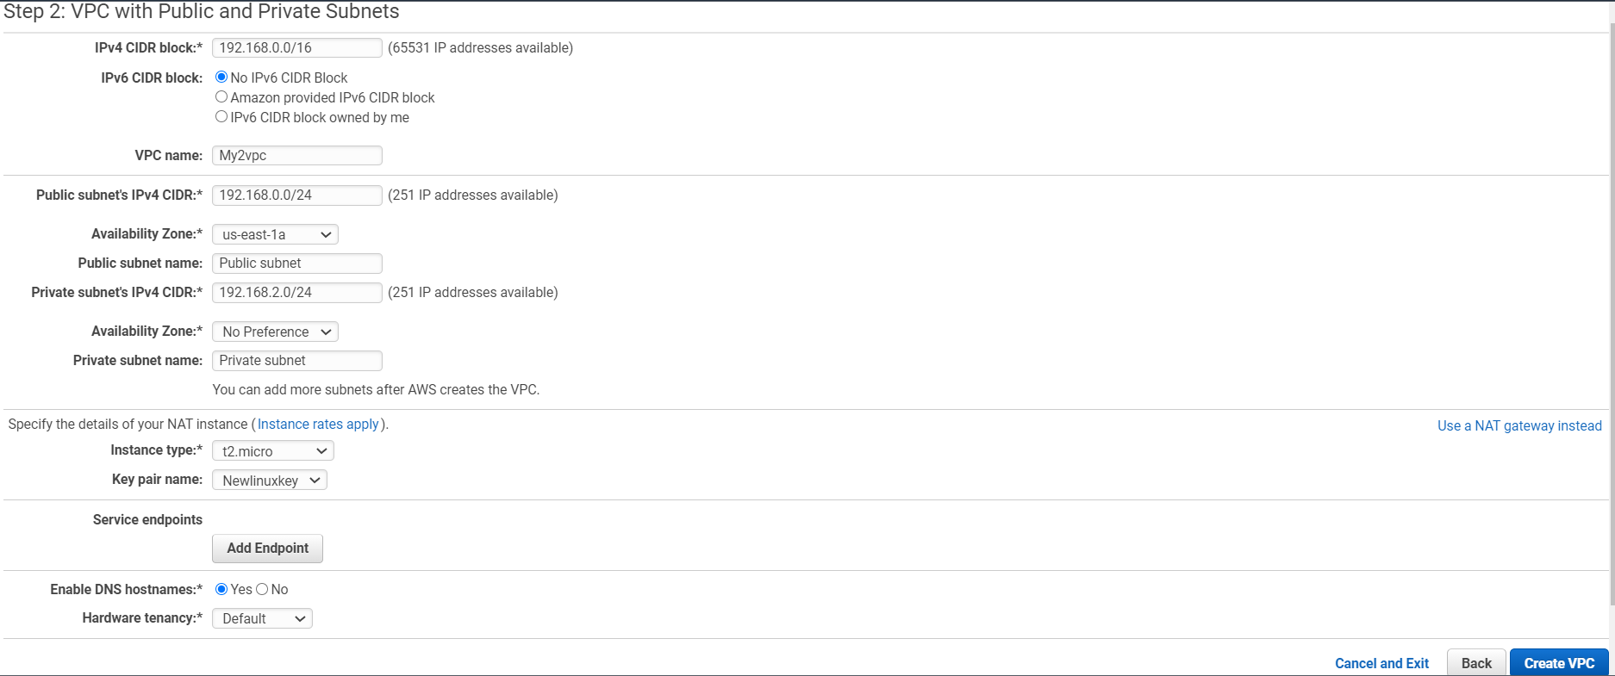

Your VPC:

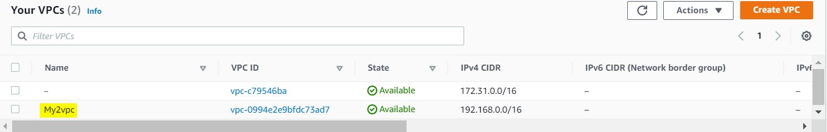

Your subnet:

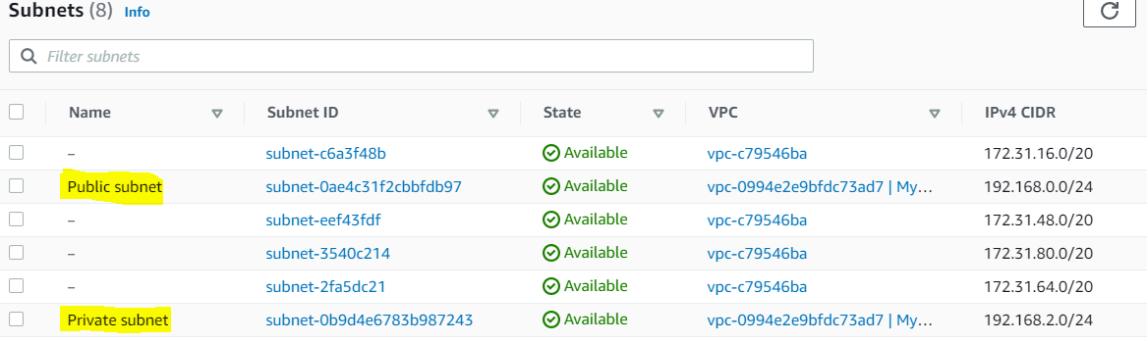

Your IGW:

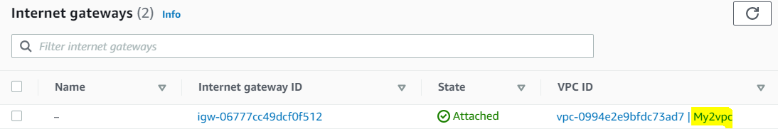

Your Route table:

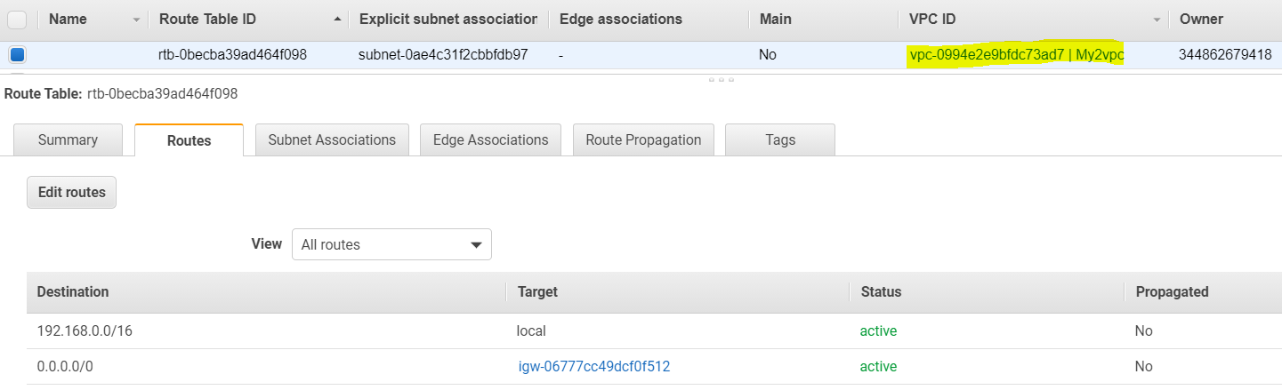

NAT instance create:

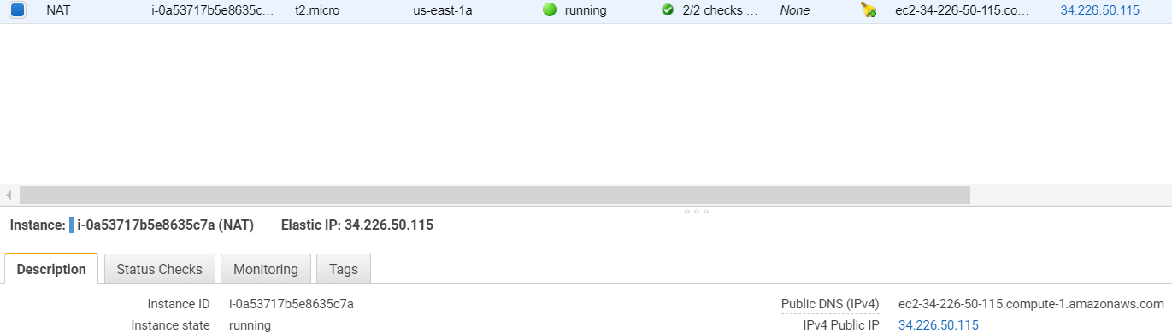

Create Public Instance and test internet connection:

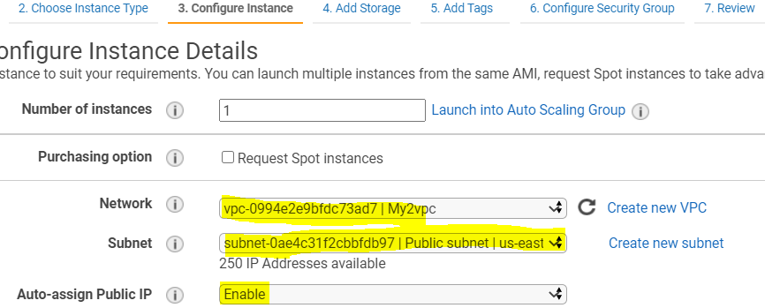

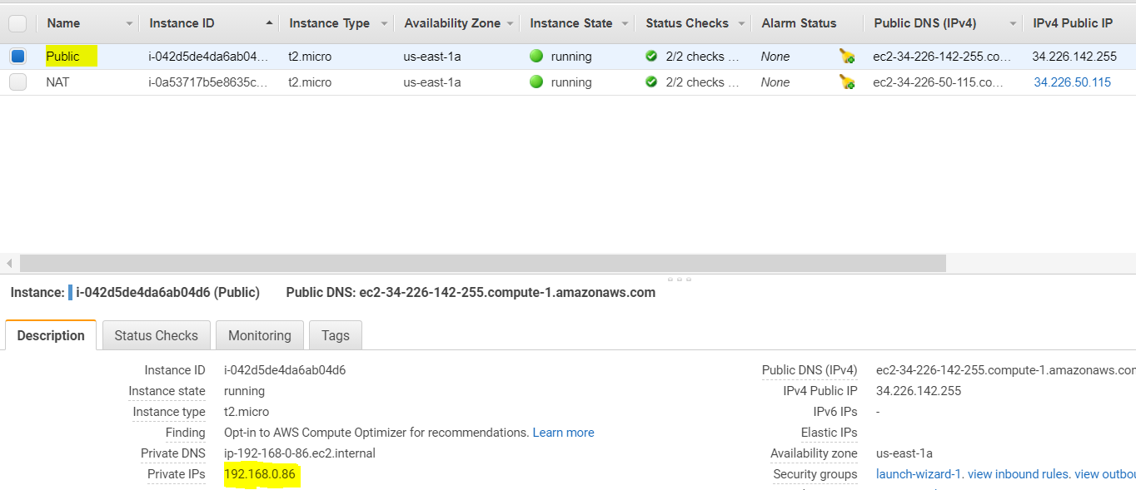

Internet Working:

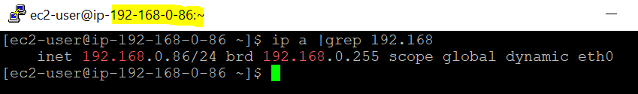

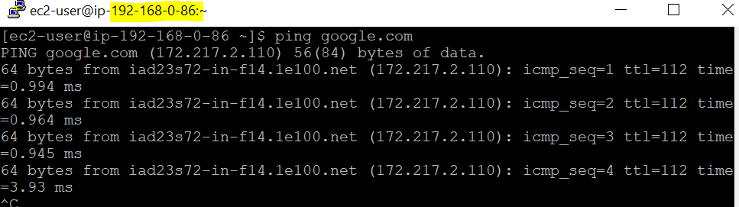

Private:

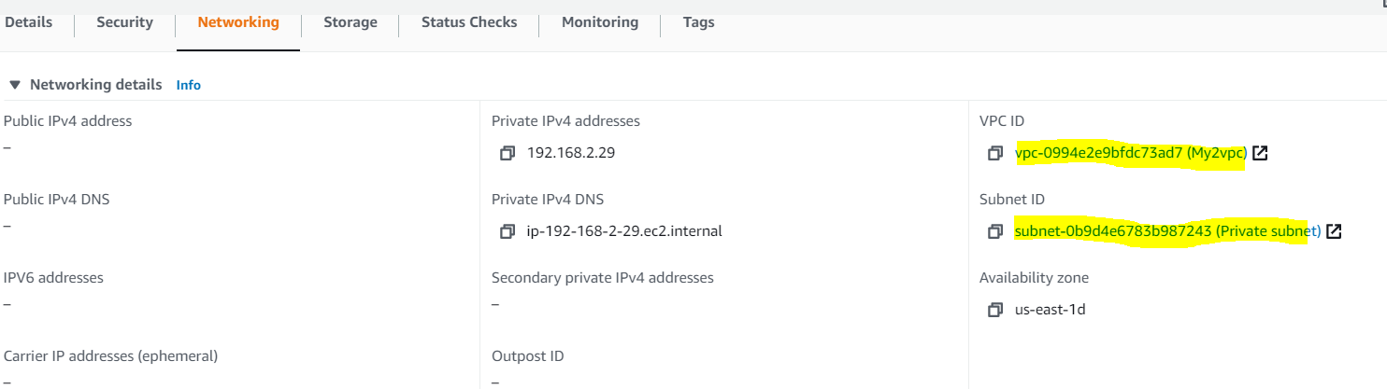

Connect your private instance from public instance:

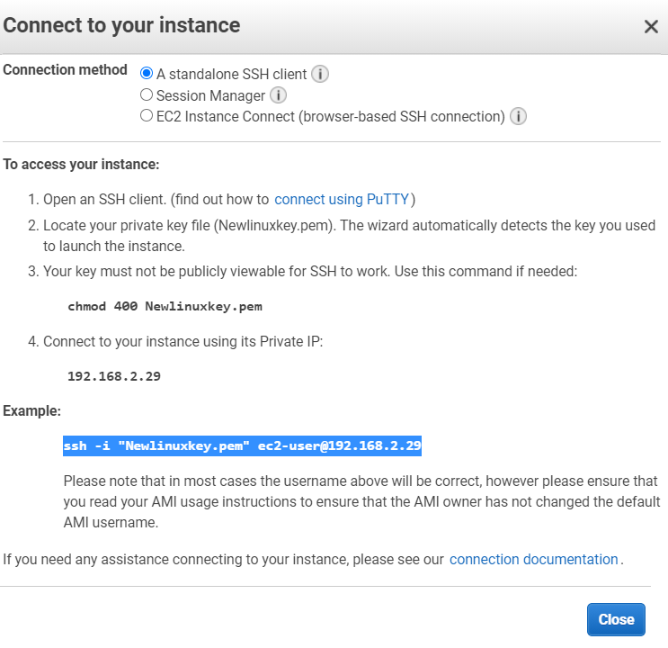

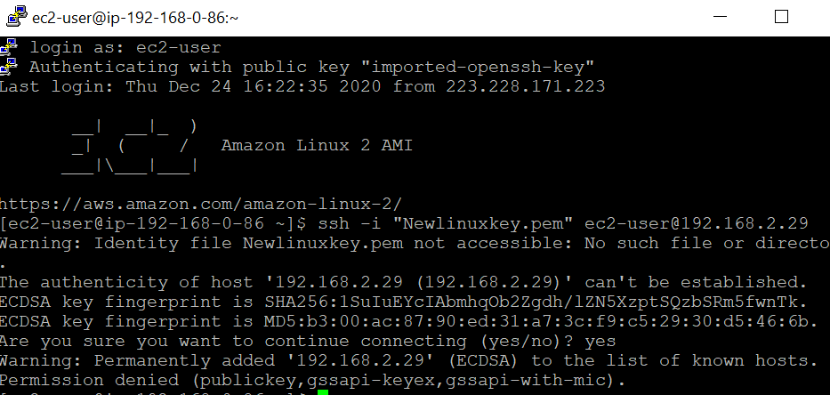

Copy the private instance keypair into public instance using Winscp and give the necessary permission and try login:

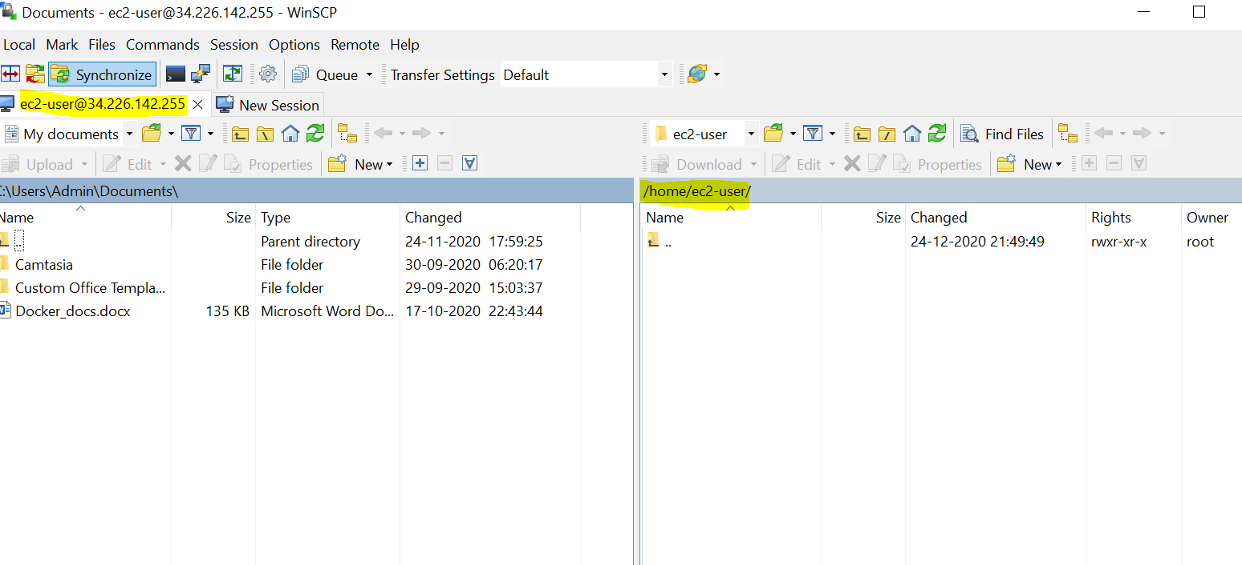

Private instance is connected from public but no internet available:

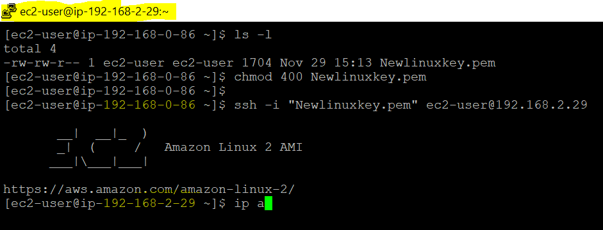

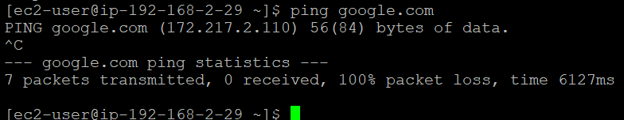

Two methods are there to get the internet for private instance.

1. Add the subnet of private instance into NAT security inbound rule -> separate rule needs to create for multiple subnets. Suitable for creating single subnet.
2. Add the private security group ID into NAT security inbound rule 🡪 no need to create the rules multiple time and assign the rule to multiple subnets.

Internet is working:

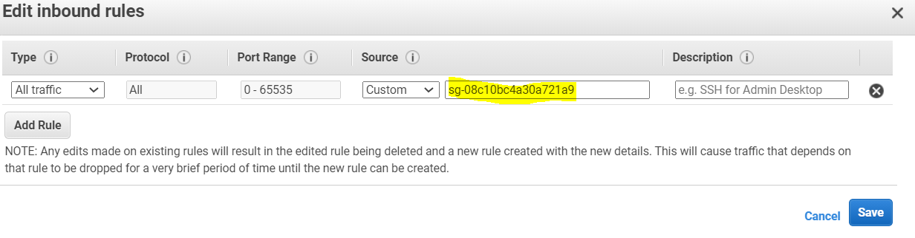

or

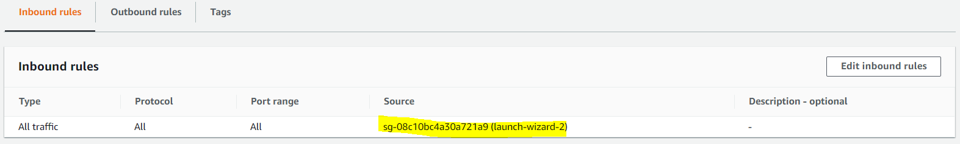

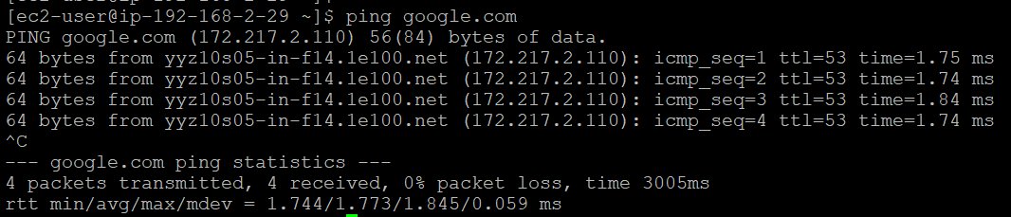

# Create a web server and an Amazon RDS DB instance

